Handout 4.1 Name:
Week # 2: 1/22/2021
Math 1150: Winter 2021 Instructor: Andrade

Introduction:
Mathematics is often used as means to explain or predict. In this exercise, you will be asked to critically analyze a scenario and, equipped with some basic facts, determine whether the prediction is plausible or not.

Having Kittens
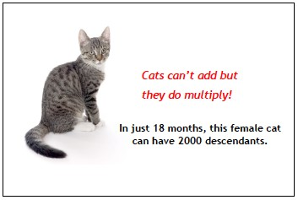
This is a poster made by a TNR program, encouraging people to have their cats spayed so they can’t have kittens. The activity is about what happens if you don’t have your cat spayed. Your task is to decide whether the statement on the poster is correct.
Is it realistic that one female cat would produce 2000 descendants in 18 months? no
Question 1. What information might you need to assess whether the statement in the poster is realistic?gestation period of a cat,how long it takes a cat to mature and be able to sire, maximum number of kittens a cat can have
Question 2. List some ways which you might be able to tackle this problem.
List some facts which will help you decide:
•gestation period of a cat is 58-67 days roughly 2 months
•a cat can give birth 3 times per year
•cats have a maximum of 12 kittens buteach litter has an average of 4-6 kittens
•age at which cats can no longer give birth is 10 years
•age at which a cat can get pregnant is about 4 months old
Question 3. Given the facts, determine whether you believe the statement is realistic or not. Explain your reasoning- mathematically, if possible.
Let's say your female cat is born at the beginning of the 18 months. By month 4, she can become pregnant, and by month 6, she can have her first litter. Let's say she has 6 kittens. Since cats tend to have 3 litters in one year, it takes about 4 months for her next round of kittens to be ready. So, by month 10, she has 6 more kittens and all of her first 6 kittens (say they're all females) get pregnant. By month 12, her first 6 kittens each have 6 kittens. By month 14, her second 6 kittens (say they're all females) get pregnant and she has 6 more kittens. By month 16, her first 6 kittens and her second 6 kittens each have 6 kittens and her first kittens' first kittens get pregnant. By month 18, she has 6 more kittens, her third 6 kittens get pregnant, and her 36 first kittens' first kittens each have 6 kittens.

That's a total of: 6+6+6 = 18 kittens from her, 6×6 + 6×6 = 36+36 = 72 kittens from her first litter, 6×6 = 36 kittens from her second litter, and 36×6 = 216, which is 18+72+36+216 = 342 kittens altogether. Not close to 2000.

But what if we assume the 18-month count starts when the female cat gets pregnant, not when she's born? That adds four more months. So...

By month 20, her first 6, second 6, and third 6 kittens all have 6 kittens and she and her first kittens' first kittens and second kittens' first kittens all get pregnant. By month 22, she and her first and second kittens' kittens each have 6 kittens.

How much did that add on?

6 kittens from her; 6×6 + 6×6 + 6×6 = 36+36+36 = 108 kittens from her first, second, and third litters; and 36×6 + 36×6 = 432 kittens from her first and second kittens' kittens, which is 6+108+432 = 546 more kittens. Still only 342+546 = 888 kittens, not 2000.

But what if we assume the 18-month count starts when the female cat gives birth, not when she gets pregnant? That adds two more months. So...

By month 24, her first kittens' first kittens' 216 first kittens each have 6 kittens, as do her first, second, and third 6 kittens.

How much did that add on?

6×6 + 6×6 + 6×6 = 36+36+36 = 108 kittens from her first, second, and third litters and 216×6 = 1296 kittens from her first kittens' first kittens' first kittens, which is 108+1296 = 1404 more kittens. That makes 1404+888 = 2292 kittens, which is definitely over 2000.

Group Work
Now you will collaborate with a group to improve your model. Take turns to explain how you did the task and how you think it could be improved. In a moment, you will put your individual work aside and try to produce a joint solution to the problem.
Question 4. Give a brief description of the approaches each member in your group used.
The cat is born within the 18 months and gets pregnant and delivers
The cat is born before the 18 months start being considered
Before attempting to improve your model, take a look at the following sample solutions and consider the following questions:
- What have they done correctly?
- What assumptions were made? Were they reasonable?
- How could the solution be improved?
Page 2
Alice
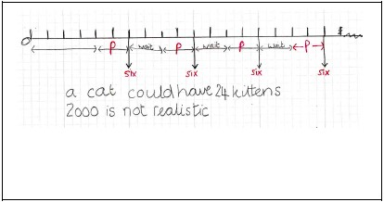
Question 5. What suggestions would you make to Alice? Alice chose to represent the task using a timeline. She has only considered the number of kittens from the original cat. She has used some of the given information correctly and has assumed that 6 cats are born at regular intervals. She has forgotten that these kittens can also have litters of their own. She has not described her reasoning and assumptions.

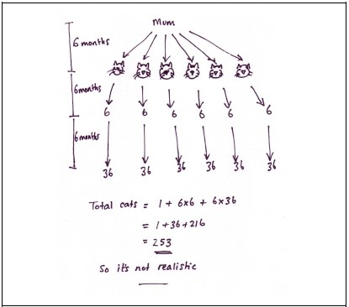

Question 6. What comments would you make to Wayne?he abandons a time consuming pictorial representation for a numerical representation. The value 216 implies a multiplication if each cat had only one litter; the total number of descendants is not found. The correct use of time is implied by three litters, but this is not explicit. There is no interpretation or evaluation, and communication is minimal. Wayne has assumed that the mother has six kittens after 6 months and has considered succeeding generations. He has, however, forgotten that each cat may have more than one litter. He has shown the timeline clearly. Wayne doesn’t explain where the 6-month gaps have come from.

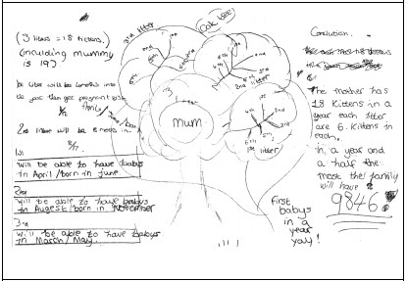
Question 7. What comments would you make to Ben? Ben has decided to draw a ‘cat tree’ and has tried to control for time (with some errors). The value 9846 is not explained and does not follow from the reasoning since, again, only the kittens from the original cat are considered. The number of kittens per litter is made explicit. Ben has included more explanation than Alice and Wayne.

Question 8. Your task now is to produce a solution that is better than your individual solutions. Explain your reasoning.
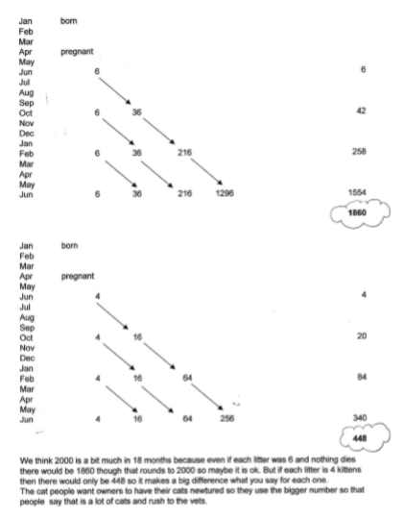
We use a spreadsheet to provide an effective way of controlling for time and multiplication; their method is clear and effective; they clearly show understanding of the process skills. The teacher discussed their choice of 6 kittens per litter – they chose the ‘worst case scenario’ but decided to investigate what would happen for 4. The difference is a good example of how changing variables makes a significant difference in multiplicative circumstances. This provides opportunities for cross-curricular discussions, eg birth rates across the world.

Handout 5 Name:
Week # 3: 1/26/2021
Math 1150: Winter 2021 Instructor: Andrade

Introduction:
Last class we got a taste of how mathematics can be used to make predictions. In this exercise, we will discuss two sample solutions to the problem from last time and how assumptions alter our predictions. Next we will formalize the concept of a mathematical model. For the next few class periods, we will be investigating some well-known mathematical models and the tools needed to operate with these models.

Having Kittens
Recall the poster we discussed last class. Today we will discuss two different approaches to the solution and how the differences in assumptions can yield dramatically different results.
Solution 1 Solution 2
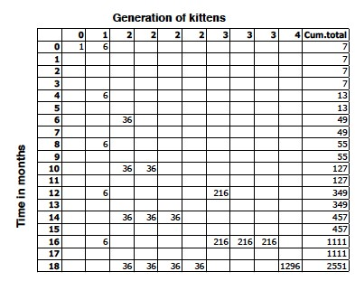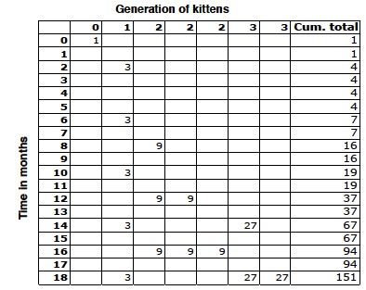
Question 1. Having worked on this problem yourself, take a moment to compare these solutions to your own. How were the difficulties you encountered handled in these solutions? Write your reflections here. Number of kittens is assumed to be 6 for each litter, a cat delivers within 4 months to make number of births per year 3.

Math 1150 Handout 5
Question 2. From the information shown in the charts, what assumptions have been made in Solution 1 and Solution 2?
Solution 1: maximum number of kittens per cat is 6
Solution 2: maximum number of kittens is 3
Question 3. What are the major differences in the assumptions of Solution 1 and Solution 2. Discuss how these assumptions impacted the final count? In the first diagram, the cat is assumed to give birth in month 0 (the first pregnancy is not counted as part of the 18-month period). In the second diagram, the cat is assumed to get pregnant in month 0, so she gives birth in month 2. • In the first diagram, the cat is assumed to have six kittens in a litter. In the second, she has only three kittens per litter.

In solution 1 the assumed number of kittens raises the total number to 2551 while in solution 2 the assumed number of kittens per cat of 3 led to a smaller total of 151
Question 4. What changes would you make to your own solution now? Explain why you would make or not make changes. Each litter would be assumed to have 5 females and one male, next generation would have 30 kittens in total and that would continue
Mathematical Models
Mathematics is most often used as a means of describing or predicting the behavior of some reallife system. The mathematical description of a system or a phenomenon is called a mathematical model.
Question 5. Can you think of an example of a mathematical model being used in your current field of study? What questions are being answered? What assumptions are being made? Model describing the space in a box V=L*W*H, questions being answered is the amount of space in a box. Assumption is tha the box has negligible thickness
Page 2
Math 1150 Handout 5
Question 6. Draw a diagram that illustrates the mathematical modeling process.
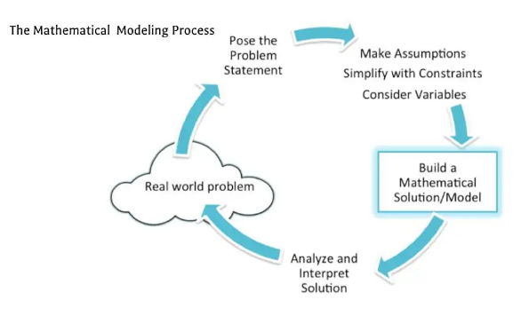

Question 7. List and describe the differences between the three types of mathematical models we discussed in class.
Insilications
Heuristics
Abstractions
For Insilications All of the unknown or system dependent parameters are related to things we can measure, and the model is then used to compute dynamics, and predict the future value of these parameters. Sometimes, as in the case of statistical or quantum mechanics, these predictions are probabilistic (for different reasons in the two theories) but are expected to agree with reality after many independent measurements
For heuristics A theorist builds up a collection of such models (or fables) that they can use as theoretical case studies, and a way to express their ideas.
An abstraction is a model that is set up so that given any valid instantiation of its premises, the conclusions necessarily follow. These models are not build to illustrate a point, but as tools to analyze any theory
What type of model would best describe the scenario of counting cat descendants? insilications
Page 3
Handout 6 Name:
Week # 3: 1/28/2021
Math 1150: Winter 2021 Instructor: Andrade

Introduction:
There are several types of functions that can be used to model relationships observed in the real world. Today we will discuss how some familiar functions are used to model real life phenomena.

Linear Functions
When we say that y is a linear function of x, we mean that the graph of the function is a line. Recall that we can represent a line by
y = mx + b,
where m is the slope and b is the y-intercept. On the other hand, if we knew that (x₁,y₁) and (x₂,y₂) are two points on a line, then the slope of that line is given by
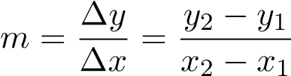
Question 1. Find the slope of the line passing through (−1,3) and (1,−1). Then sketch the graph.
.
M=3-(-1)/-1-1=-2
A characteristic feature of linear functions is that they grow at a constant rate. In other words, we should consider linear functions as descriptive tools for situations where the quantity of interest is changing at a constant rate.
Question 2. Do you think a linear function would be a suitable model to describe the number of descendants one female cat can have in 18 months? Why or why not? Yes, there is a constant rate of change of 6 kittens in 4 months
Math 1150 Handout 6
Question 3. As dry air moves upward, it expands and cools. If the ground temperature is 20◦ C and the temperature at a height of 1 km is 10◦ C, express the temperature T (in ◦ C) as a function of height h (in kilometers), assuming that a linear model is appropriate.
M=10-20/1=-10⁰c/km => T=-10h+20
- Use your model to predict the temperature at a height of 2.5 km.
T=-10*2.5+20= -5⁰c
Question 4. The given table lists the average carbon dioxide level in the atmosphere, measured in parts per million at Mauna Loa Observatory from 1980 to 2012. Use the data to find a model for the carbon dioxide level.
 | 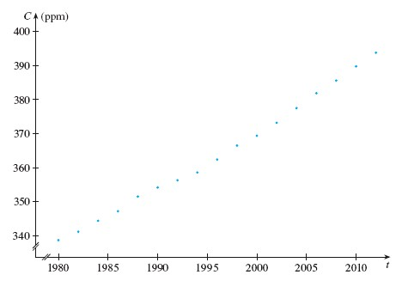
  Year | CO₂ Level (in ppm) | Year | CO₂ Level (in ppm)
  1980 | 338.7 | 1998 | 366.5
  1982 | 341.2 | 2000 | 369.4
  1984 | 344.4 | 2002 | 373.2
  1986 | 347.2 | 2004 | 377.5
  1988 | 351.5 | 2006 | 381.9
  1990 | 354.2 | 2008 | 385.6
  1992 | 356.3 | 2010 | 389.9
  1994 | 358.6 | 2012 | 393.8
  1996 | 362.4
- Do you believe that a linear model appropriate for this data? Why or why not?yes the graph describing it is linear
Page 2
Math 1150 Handout 6
- Use the data to find a model for the carbon dioxide level
M=(373.2-341.2)/20= 1.6ppm/year
Model: y=1.6t+338.7 where t is the number of years from 1980
- Using a linear regression calculator, compute the regression line.
Y=1.59707T+336.22203
- Use the model in part (c) to predict when the level of CO₂ will exceed 420 parts per million.
Y=420 X=(420-336.22203)/1.59707=52
1980+52=2032
- Between the models found in part (b) and part (c), which would you expect to be more accurate? Explain why. The one found in part c since it is more precise
Choosing the right function for the job.
Linear functions certainly cannot accurately describe every situation we encounter. However, you probably have some familiarity with the toolbox of functions we will need.
Question 5. Consider a function h(t) that models the height of a person given their age in t years. Draw a sketch of what the function might look like.
y
x
Page 3
Handout 7 Name:
Week # 5: 2/11/2021
Math 1150: Winter 2021 Instructor: Andrade

Introduction:
As was discussed in the readings, Newton developed calculus in part to answer questions he had about motion and rates of change. On Tuesday, we discussed some of the mathematical handicaps Newton experienced and the techniques developed to tackle this problems. In this handout, you will apply those techniques to make predictions about the rate of change.

Rates of Change and Tangent Lines
Recall that the tangent line to a curve is one that touches the curve at a point and captures the "slope" of the curve (at that given point). A secant line is a straight line passing through two points on the given curve.
Question 1. Suppose the graph g below describes the distance a free-falling object travels after t seconds of flight. In class on Tuesday, we talked about how the secant and tangent lines hold important information about the motion of the object. Answer the following questions.
- What information does the secant line (shown in the figure) between the two points when t = 1 and t = 2 tell us about the speed of the object during this period?
-1.5
-1
-0.5
0.5
1
1.5
2
2.5
3
3.5
4
-2
2
4
6
8
0
g
,
2)
(1
8)
,
(2
-0.8
-0.6
-0.4
-0.2
0.2
0.4
0.6
0.8
1
1.2
1.4
1.6
1.8
-2
-1
1
2
3
4
0
g
f
(1
2)
,
M=(8-2)/(2-1)=6 m/s
b) What information does the tangent line (shown in the figure) when t = 1 tell us about the speed of the object?
Speed=2-(-2)/1-0=4m/s
c.) In your own words, describe how the secant lines are used to obtain the slope of the tangent line. You may want to include a graph. A right angle triangle describing the two connected points is drawn with its hypotenuse being the secant line and its slope determined.
Math 1150 Handout 7

Following Newton’s Approach
Question 2. Suppose that a ball is dropped from the upper observation deck of the CN tower in Toronto, 450 m above the ground. Galileo’s law states that the distance fallen after t seconds can be represented as s(t) = 4.9t²,
where s(t) is given in meters.
- Compute the average speed the ball travels between t = 5 and t = 6. You may use a calculator, but include your calculation steps below. Your final answer should include units.
S(6)=4.9*6²=176.4
S(5)=4.9*5²=122.5
Speed=(176.4-122.5)/1=53.9m/s
- Complete the following table. You may use a computing device or calculator and do not need to include your calculations for this part.
Interval | Average Speed
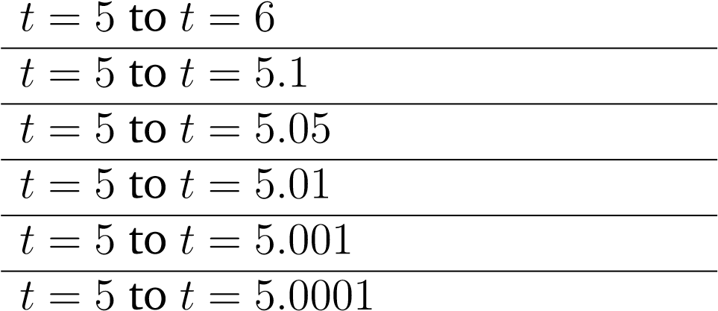 | 53.9  49.49  49.245  49.049  49.0049  49.0049
- Use the previous part to determine the instantaneous speed (or velocity) when t = 5? Your answer should include units. 49m/s

- Based on the graph of the function s(t), how do you think the instantaneous speed of the ball when t = 9 compares to speed of the ball when t = 5? You may want to graph the function using a graphing utility. Do not base your answer on intuition, but instead use the graph to support your answer.
Page 2
Math 1150 Handout 7
They are linearly related passing through the speed points for t=6,7,8 seconds
Using the rate of change to predict the future.
Question 3. Consider a population of bacteria in a homogeneous nutrient medium. Suppose that by sampling the population at certain intervals it is determined that the population doubles every hour.
- If the initial population is 10 and t is measured in hours, how many bacteria will be present after 1 hour? After 2 hours? After 3 hours?
      - hour pop =20
      - 2 hours=40
      - 3 hours=80
- Use the previous part, to devise a model (or function) P(t) that describes the number of bacteria present after t hours. In other words, find a pattern using part (a) so that you can mathematically describe the number of bacteria after t hours. P(t)=10*2^{t}
- Using your model from part (b), predict how many bacteria will be present after 24 hours.
P(24)=10*2^24=167772160
- In your own words, what does the rate of change of P(t) represent? Is the rate of change constant? Explain your reasoning. Rate of change is not constant since it keeps on doubling every hour but the descriptive graph is linear
Page 3
Handout 8 Name:
Week # 6: 2/18/2021
Math 1150: Winter 2021 Instructor: Andrade

Introduction:
On the last handout, we saw a scenario where bacteria in a petri dish double every hour. This example illustrates that not all functions can be represented by linear functions. Today we will investigate the rate of change of exponential functions and determine when these functions might help in describing real-life scenarios.
Question 1. Use the function y =2^{x} to answer the following questions.
- Complete the following table for the y-values of the function y =2^{x}.Then using the points in your table, graph the function.
 | 0  4  8  12  16  20  24  28  32
  x | y =2^{x}
  0  1  2  3  4  5 | 2⁰ =1  2¹=2  2²⁼4  2³⁼8  2⁴=16  2⁵=32
1 2 3 4 5 6 7
- Next compute the slopes between each of the points above. What do you notice?
Points | Slope
x=0 to x=1  x=1 to x=2  x=2 to x=3  x=3 to x=4  x=4 to x=5 | 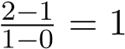  (4-2)/2-1=2  (8-4)/(3-2)=4  (16-8)/(4-3)=8  (32-16)/(5-4)=16
Exponential functions take the form y =a · b^{x}. For our purposes we will assume both a and b are positive numbers.
Question 2. What does the parameter a represent? The original value being considered Specifically what does a tell you about the graph of the function y =a · b^{x}? The starting point on the positive Cartesian plane What might a represent in a real life scenario? The original population of a given colony of bacteria
Question 3. From the previous exercises, what do you know about the rate of change of an exponential function? For example, is it constant? No, it doubles up Can you describe the rate of change of y = ab^{x} in terms of a and b? Rate of change=ab^{x}/a=b^{x}
Math 1150 Handout 7
Question 4. Use a graphing utility to investigate each of the following cases. Draw a sample graph for each
0
<
b
<
1
b
=1
1
<
b
Question 5. Several scenarios are given below. Identify each as best modeled by a linear function, an exponential function, or neither. Explain your choice. You may want to suggest an equation to support your argument.
- A gym membership costs $ 50 to open then $ 25 per month thereafter.linear function
- The number of kids at a theme park triples every hour. Exponential function
- In the year 2000, an apple cost 10 cents. Today, it costs 50 cents. linear
- A rocket accelerates from the surface of the moon. neither
- The number of descendants a single cat can have in 18 months . linear
Page 2
Math 1150 Handout 7
- A rock is dropped from a cliff.neither
- Every year, a sandwich shop doubled its profits. exponential
- The more money a car manufacturer spends on advertising, the more cars they sell. exponential
- The more rainfall there is in the morning, the more students are late to school. linear
- A plane descends 2 meters vertically for every 5 meters of horizontal movement.linear
- In the springtime, the number of ants in a colony quadruples every week. exponential
- In the fall, the number of leaves on a particular tree is halved every week. expontial
Page 3

